III B.Tech II Semester Regular Examinations – May, 2024
DEEP LEARNING
Time: 150 Min (CSE) Max. Marks:80M

SECTION – A
Answer all Four questions 4×10M=40M
- In a movie streaming service, users often rely on various factors to decide whether they'll enjoy a particular movie. One such factor is the involvement of specific actors and directors. Imagine a new movie titled "Galactic Adventure" directed by Rajamouli and starring Prabhas. The streaming service is eager to predict how users will respond to this movie based solely on the involvement of these two renowned figures. The service collects data from past movies featuring Rajamouli and Prabhas, noting whether users liked or disliked these movies. Here's a snapshot of the data: Help the streaming service team by performing the following operations based on the collected data.
Name of the movie | Director | Actor | Like/Dislike
Baahubali: The Beginning | Rajamouli | Prabhas | Like
Baahubali 2: The Conclusion | Rajamouli | Prabhas | Like
Saaho | Sujeeth | Prabhas | Dislike
Mirchi | Koratala Siva | Prabhas | Like
Eega (Makkhi) | Rajamouli | Nani | Like
RRR | Rajamouli | Ram Charan &Jr. NTR | Like
Galactic Adventure | Rajamouli | Prabhas | ?
- What are the interesting patterns in the data? (2M)
- Find the like/ Dislike for a movie “Galactic Adventure” after construction of McCulloch-Pitts(MP) Neuron. (4M)
- Prove that the designed MP Neuron is able to classify all the instances correctly. (4M)

- In a densely populated urban area where Dengue fever is prevalent, a local healthcare provider is looking to enhance their early detection and response to Dengue cases. They decide to implement a machine learning approach that predicts Dengue disease based on the symptoms reported by patients. Help the healthcare provider by designing a model which predicts the disease based on the symptoms provided in the below table such as fever, headache, muscle and joint pain and rash.
Fever | Headache | Muscle/joint pain | Rash | Dengue
Yes | No | No | No | No
Yes | Yes | No | No | No
Yes | No | No | Yes | No
Yes | Yes | Yes | No | Yes
Yes | Yes | No | Yes | Yes
No | Yes | Yes | Yes | Yes
Yes | Yes | Yes | Yes | Yes
Yes | No | Yes | Yes | ?

- Design a perceptron which classifies all the instances correctly provided in the table? (5M)
- Predict the disease for the last instance of the provided table? (2M)
- Write the perceptron convergence theorem. (3M)
- a) Construct layer diagrams of AlexNet, and VGG19 models to classify Image Net data and also notify the model with high computation complexity out of the two. (2M)
b) Further, compare the complexity of above two models in terms of depth, layer count, trainable parameters and performance etc. (2M)
c) What are the desirable features of activation functions? Explain any two linear and nonlinear activation functions with its derivatives? Explain which activation functions avoids the Vanishing Gradient Problem. (6M)

- A neural network simulation with the inputs (X₁, X₂, X₃) = (1,0,1), initialized with the random branch weights as per the following figure.
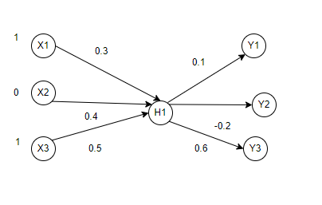
- Compute the loss by adding L2 Regularization term to the objective function. (4M)
- Explore the above network generalizes well or not based on the Loss? (2M)
- Update the weight associated with H1-Y1 and X1-H1 using an Adam as optimizer (consider the activation function= ReLU,
Learning rate=0.9, $β_{1}=0.9, β_{2}=0.99 , =0.1$) (4M)

SECTION – B
Answer all Two questions 2×20M=40M

- Design a deep neural network for predicting whether a person can go for outdoor activities like playing based on weather features such as temperature, humidity, wind speed, and atmospheric pressure. Let the values for features are [temperature= {Hot, Cool, Mild}, Humidity = {High, Normal}, Wind speed = {Low, High}, Pressure= {High, Low}]
Structure of the network is as follows
Input layer with four nodes, each represents feature
One Hidden layer with two nodes
- Node 1: (Weight W1=-0.2, W2=0.3, W3=0-.4, W4=0.1)
- Node 2: (Weight W5=-0.1, W6=-0.2, W7=-0.1, W8=0.3)
One node at output layer for the prediction
- Node 3: (Weights: W9=-0.1, W10=0.2)
Use the sigmoid as activation function, loss as Mean Squared Error, target as 1, and learning rate as 0.9
- How to convert a conventional neural network as a deep neural network? (2M)
- Construct a deep neural network for the above data scenario. (2M)
- Give the conclusion that whether a person can go for outdoor activities or not based on the loss with the given weather conditions such as [Temperature=Cool, Humidity=High, Wind speed=Low, Pressure=High]. (8M)
- Apply the Gradient Descent as optimizer to update the random initialized weights to reach the target. (8M)

- Given an auto encoder, with the inputs (X₁, X₂, X₃) = (1,1,0) and the given set of weights in the diagram.
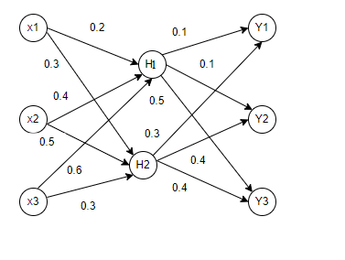
- What are the basic design challenges of Auto Encoder when compared to conventional neural networks and verify whether the given Auto Encoder is Under Complete or Over Complete? What is the type of loss function when the inputs are real. (4M)
- Compute the Error/Loss occurred at the output layer. (6M)
- Apply the TanH as activation function and Adagrad as optimizer to update the weights (learning rate=0.9, vt=0,∈=0.1) (8M)
- Explain the purpose of adding noise to the inputs and mention the different ways? (2M)

